**Download chrome Driver for chrome browser**

**Step1 : check your chrome browser version.**

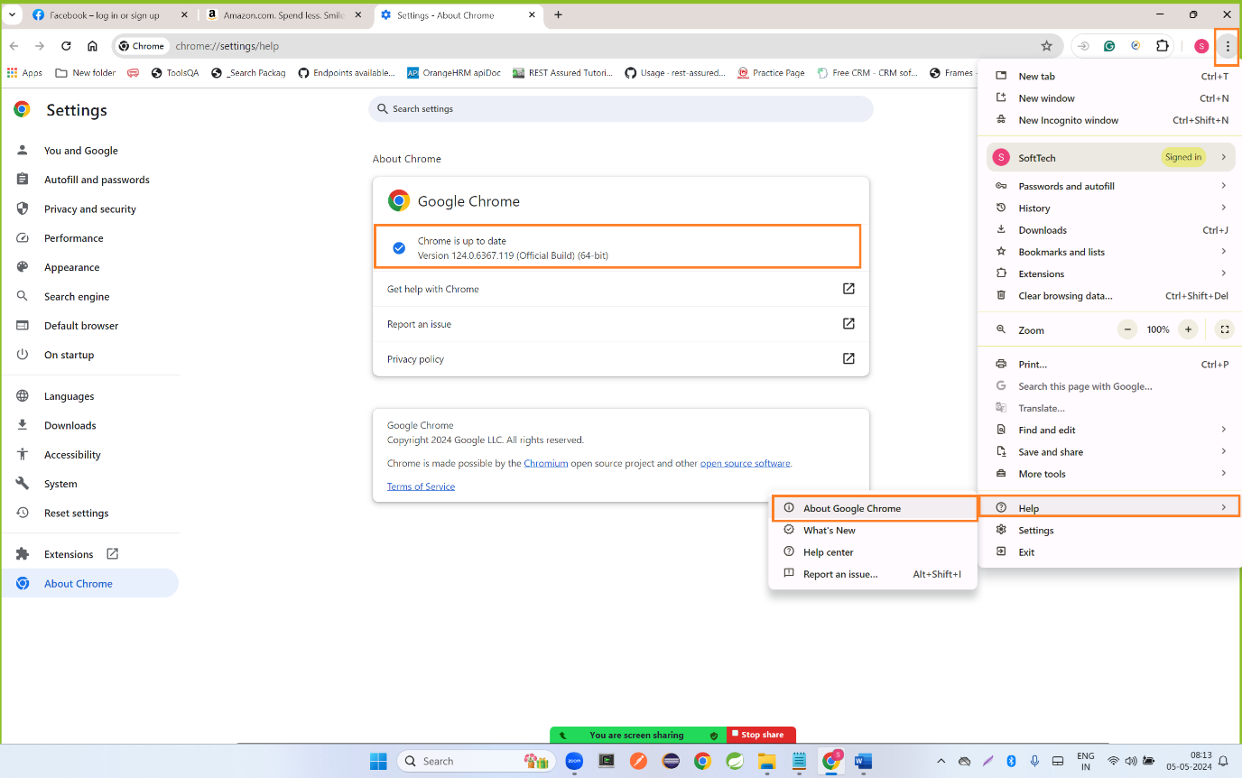

**Step 2: open a below URL**

[**https://chromedriver.chromium.org/**](https://chromedriver.chromium.org/)

**click on below link**

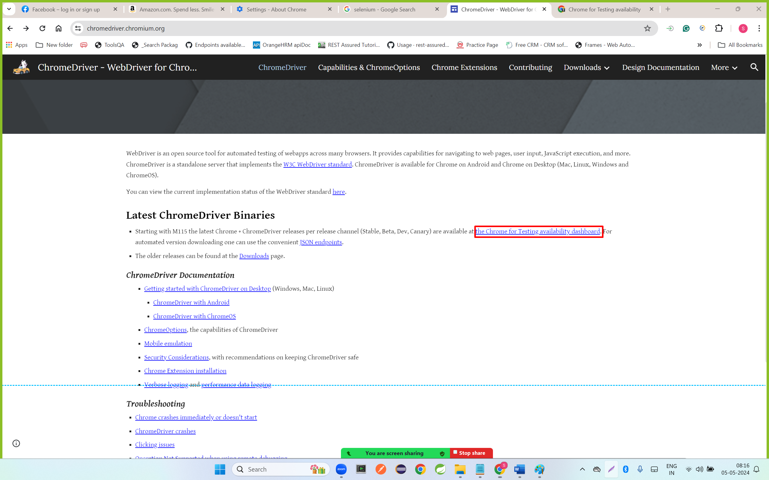

**Step 3: copy the below link and paste in new tab. And it will start downloading chrome driver.**

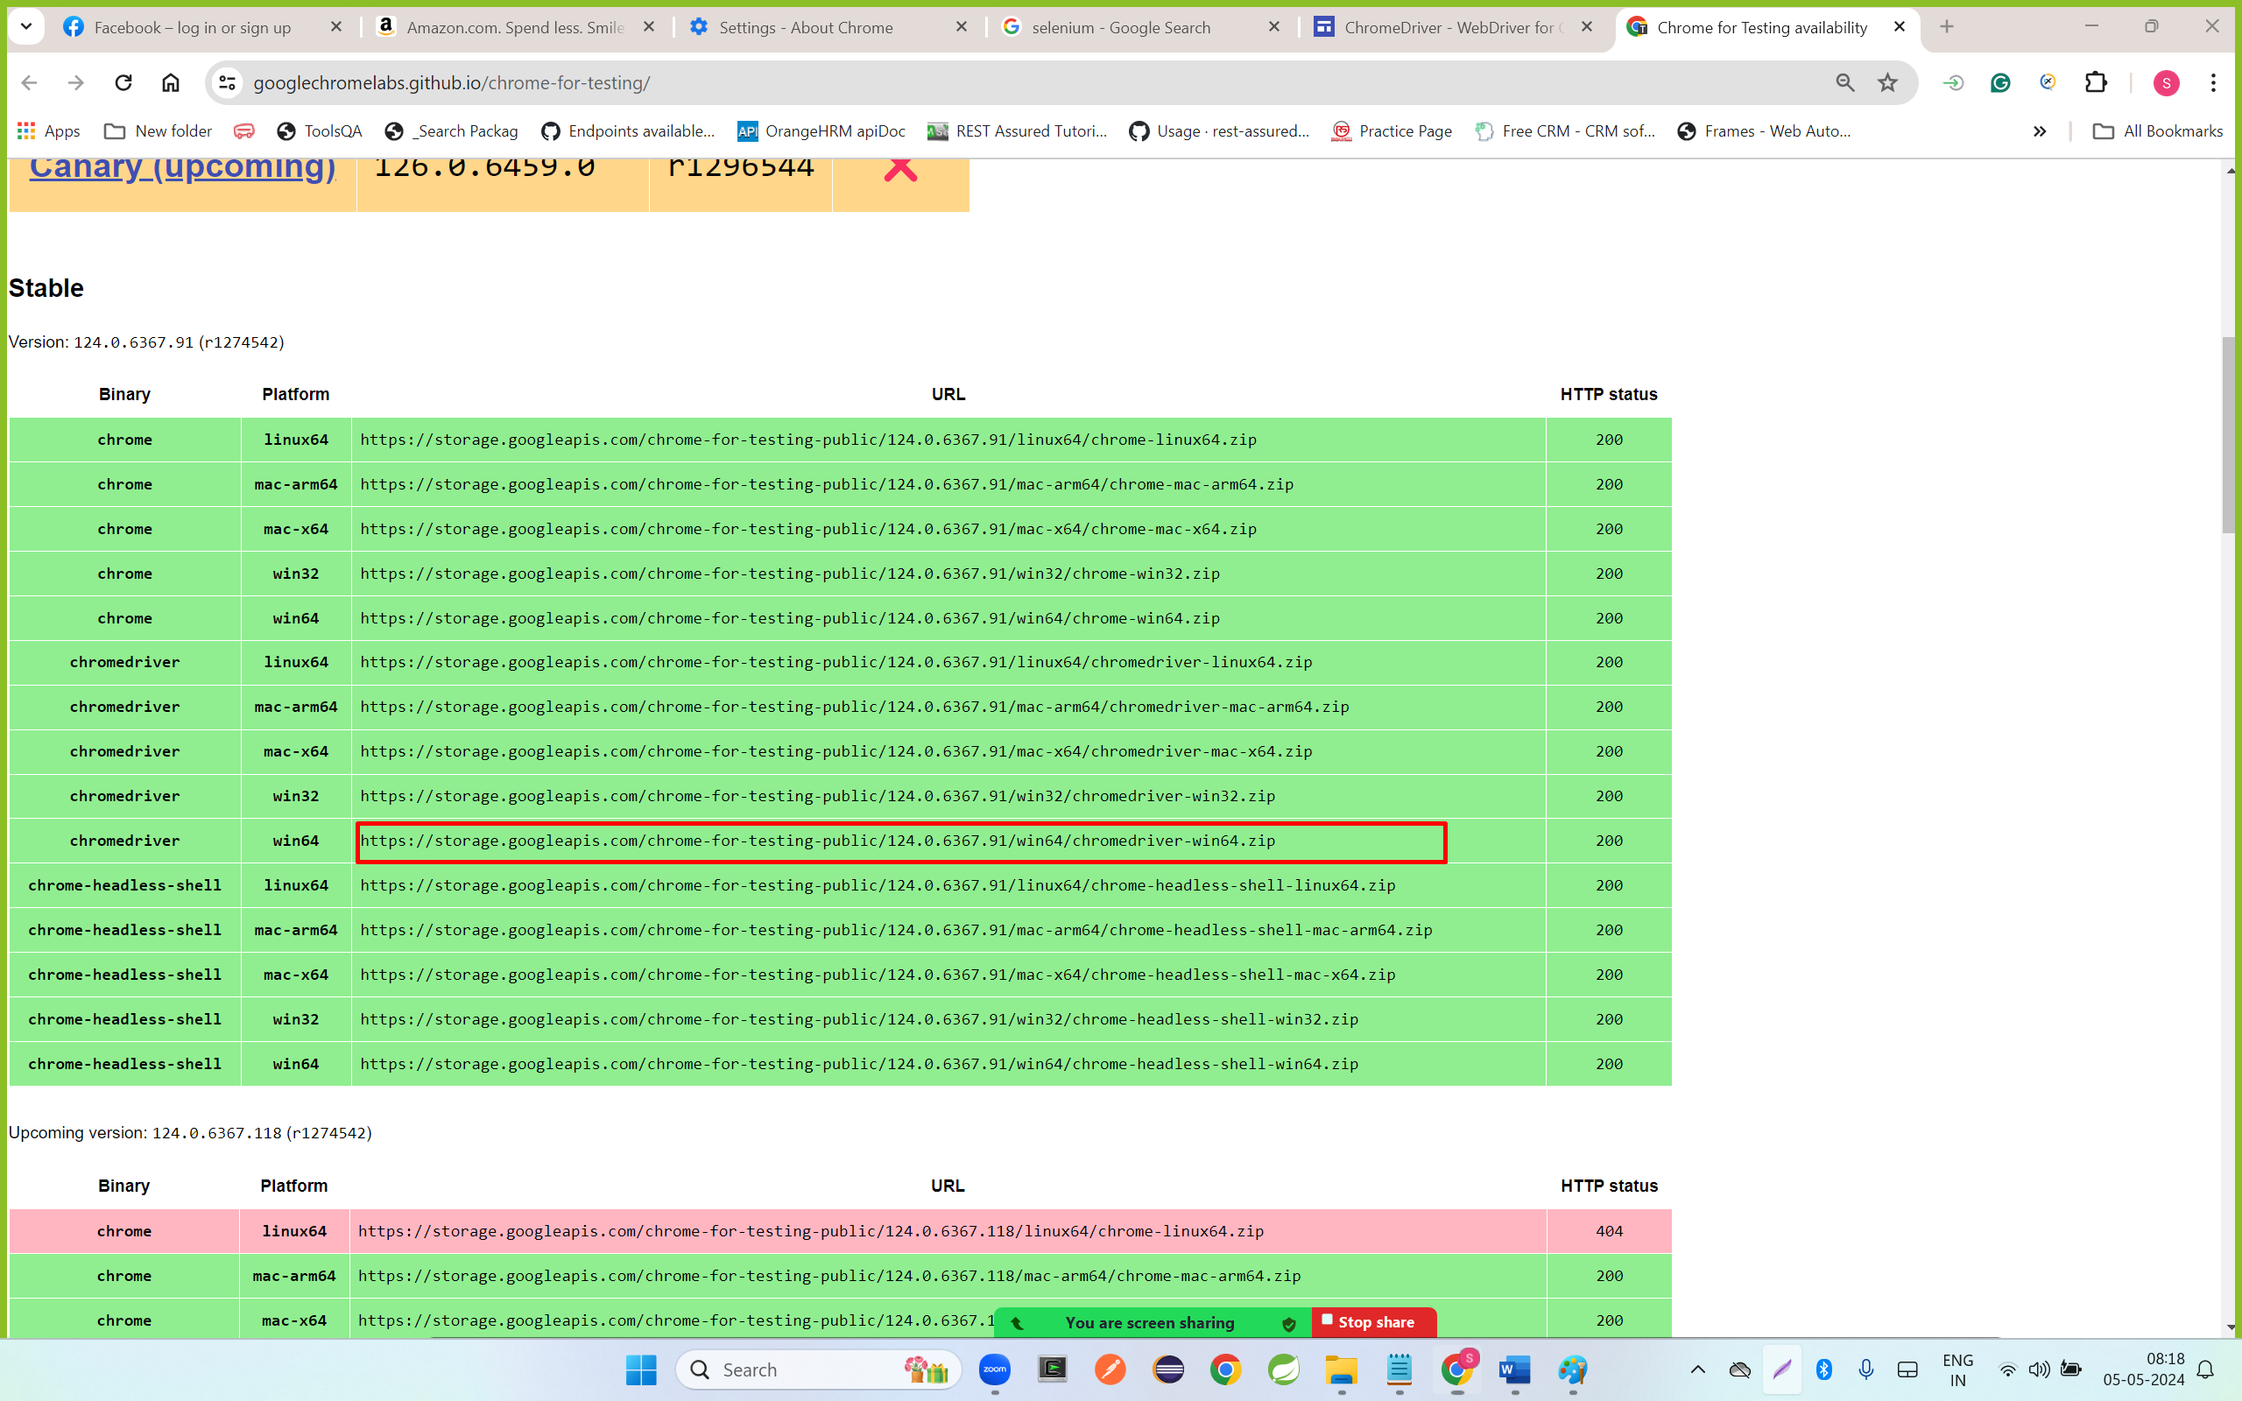

**Step 4: right click on download file and click on extract all**

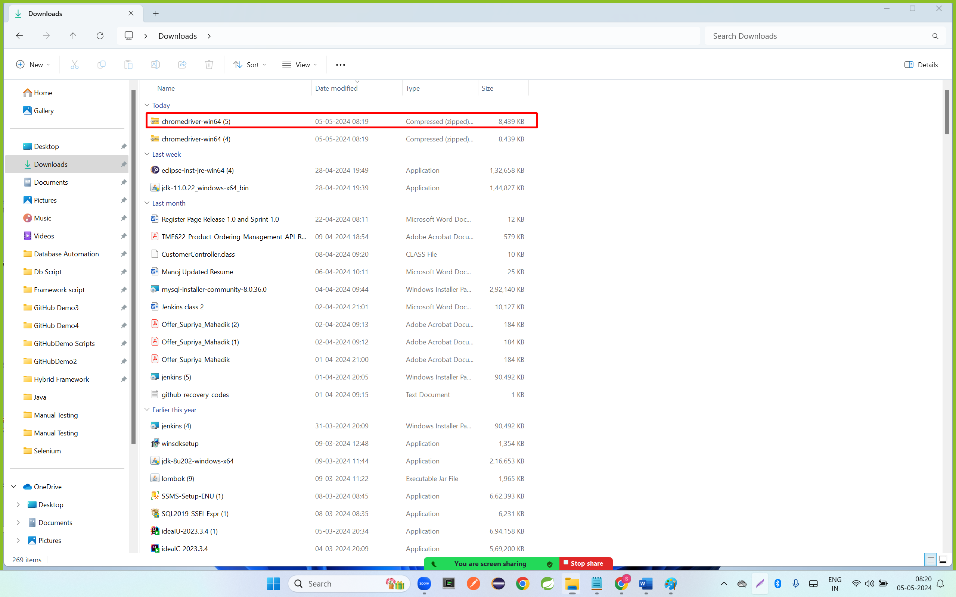

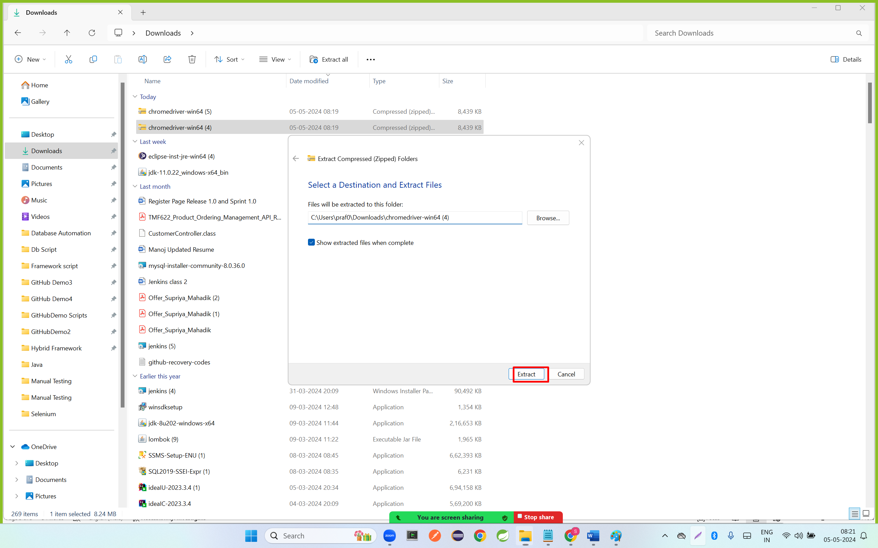

**Step 5:copy the folder and paste in desktop location**

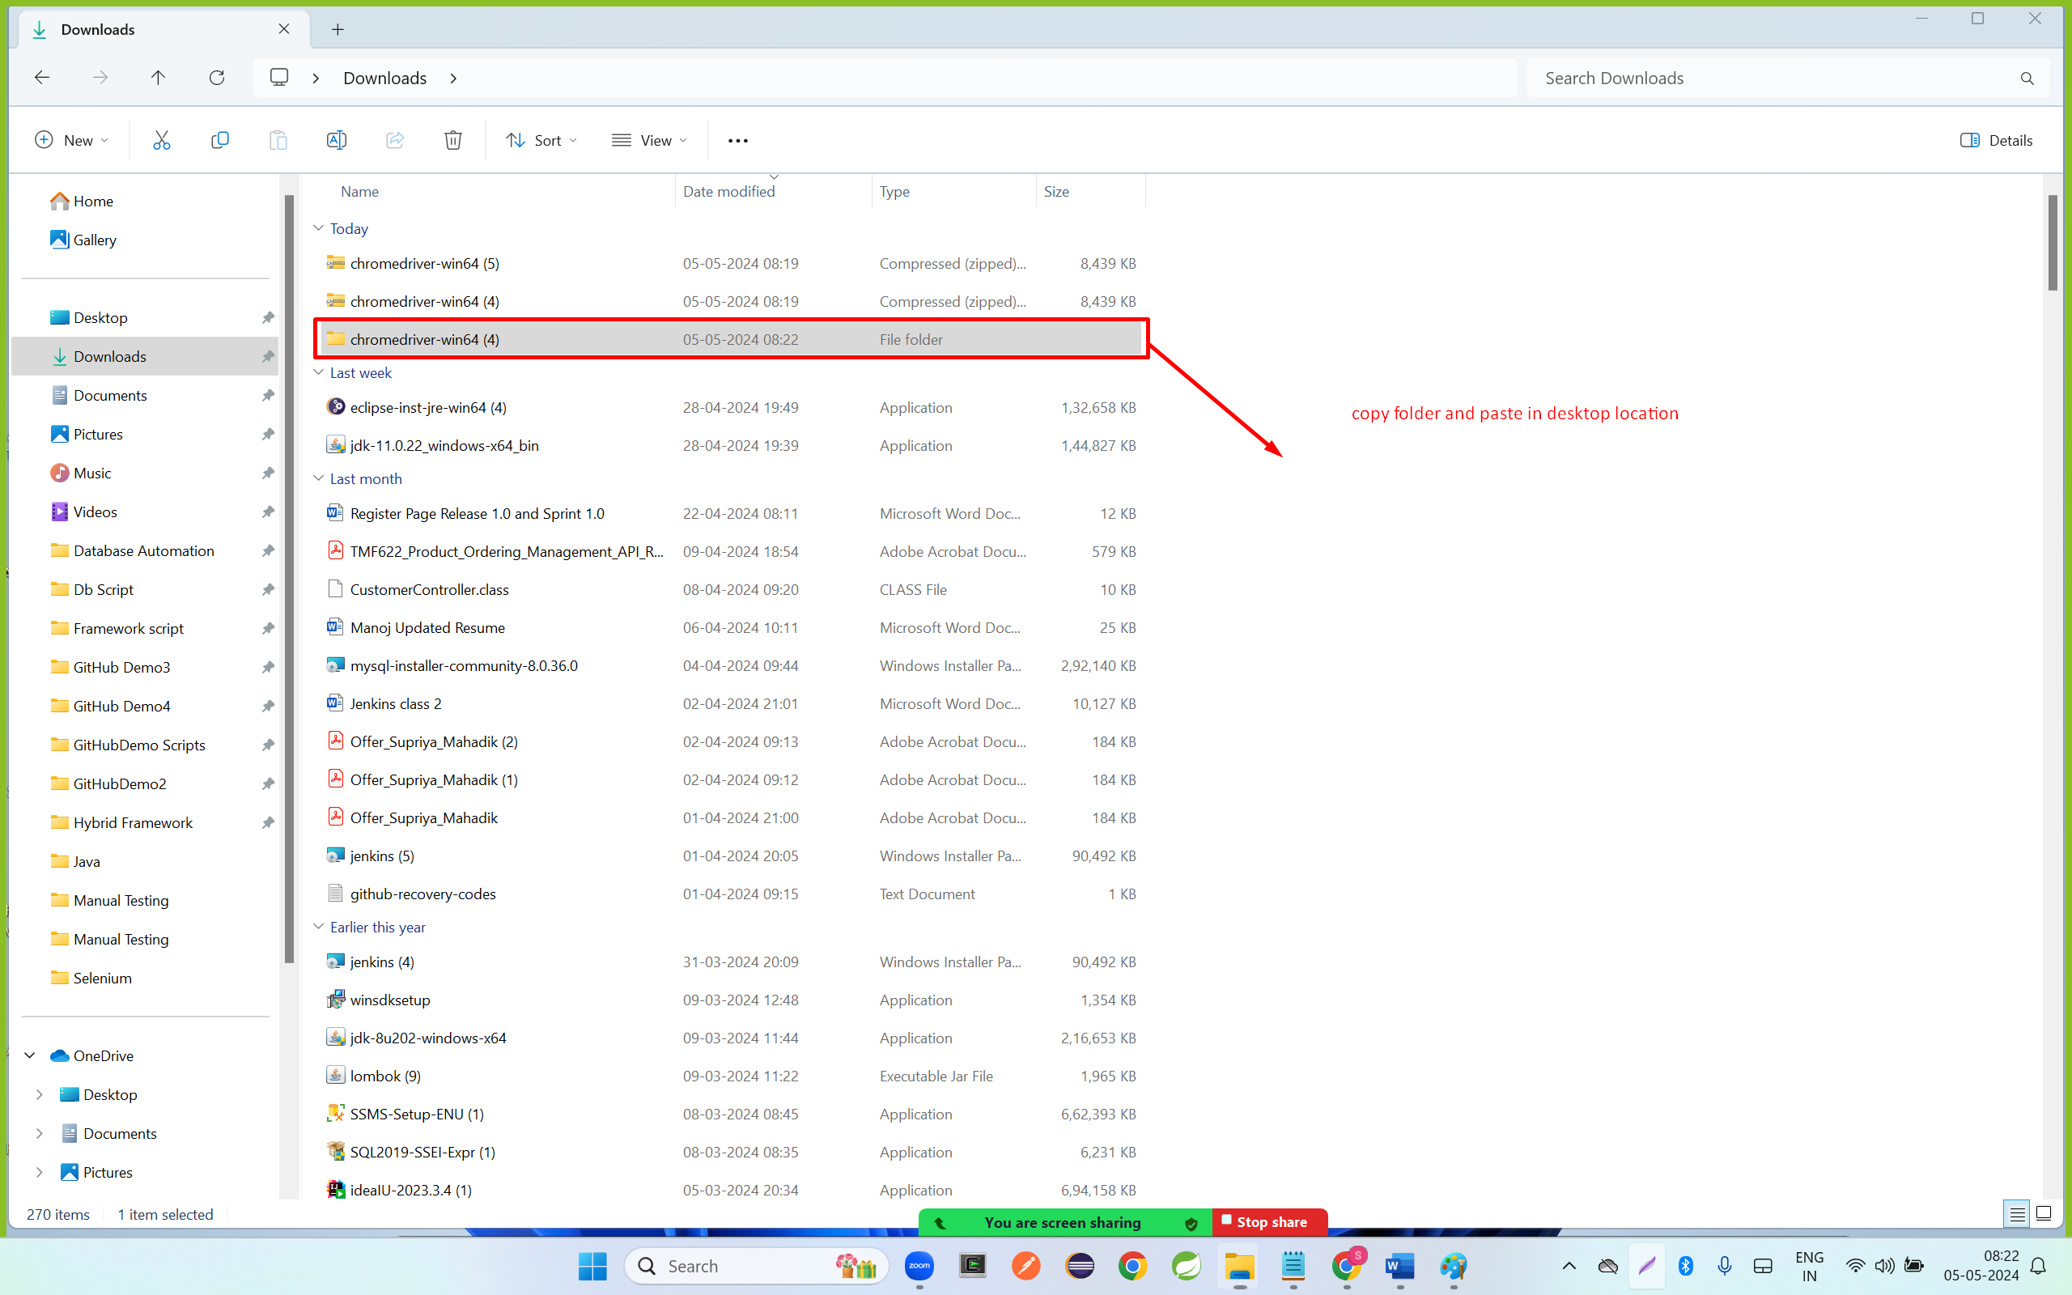

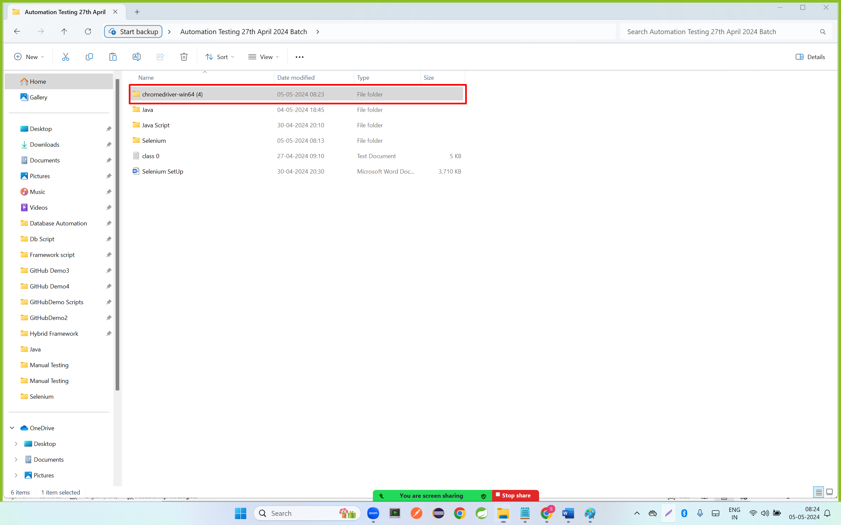

**Step 6: open a chrome driver folder and copy the path of chromedriver.exe file**

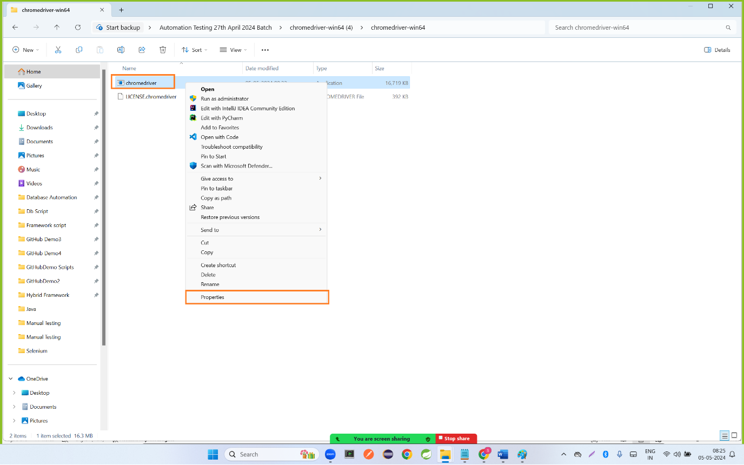

**Click on security option and copy the end to end path**

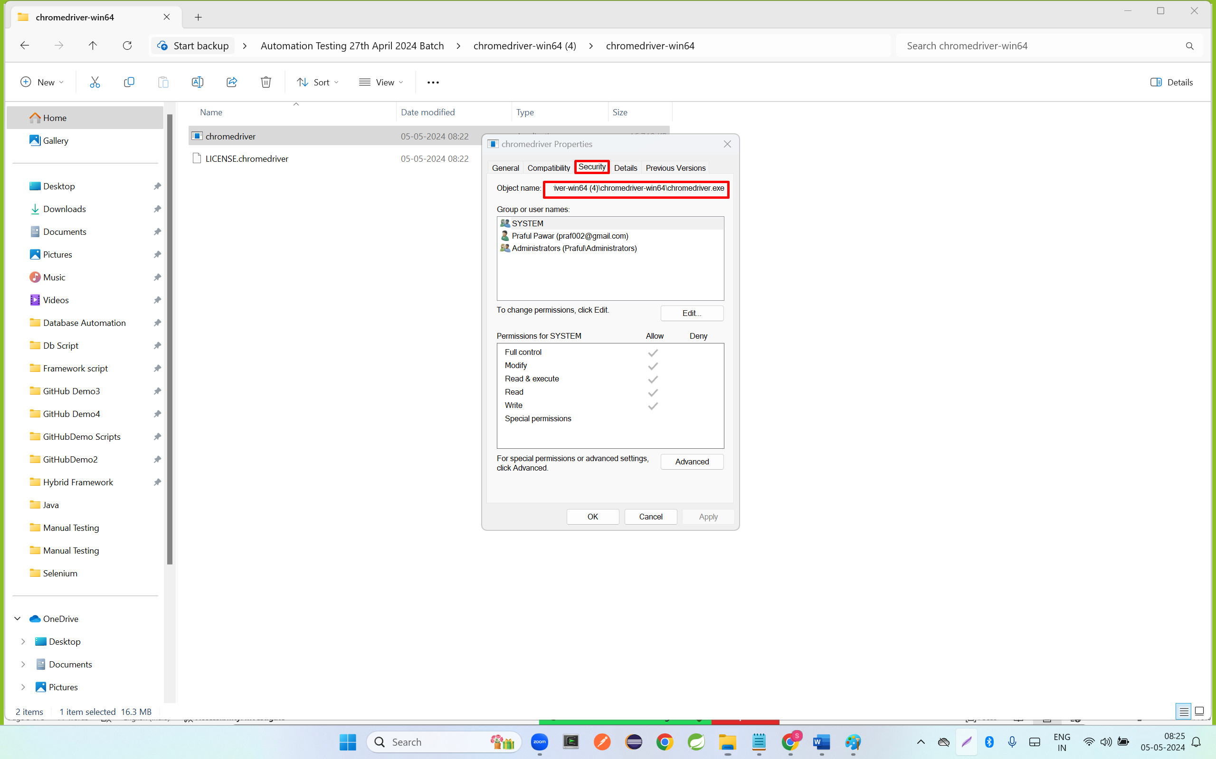

**Create Maven Project**

**Step 1: click on file ,go to new and click on maven project**

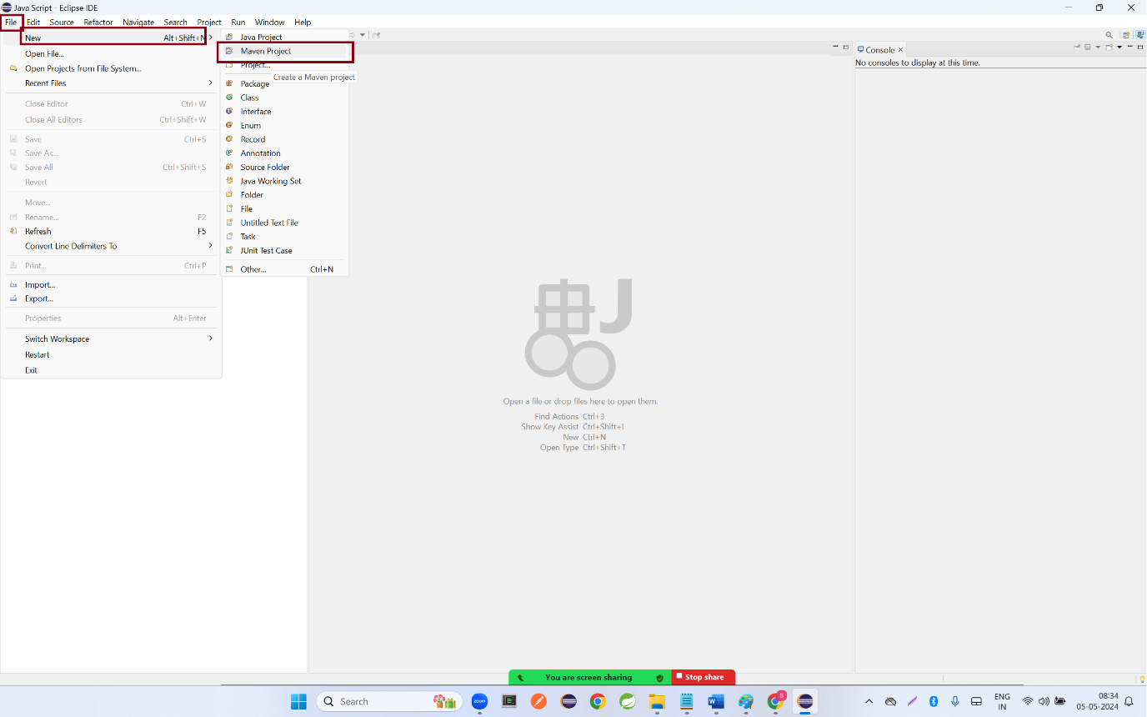

**Step 2: click on next button**

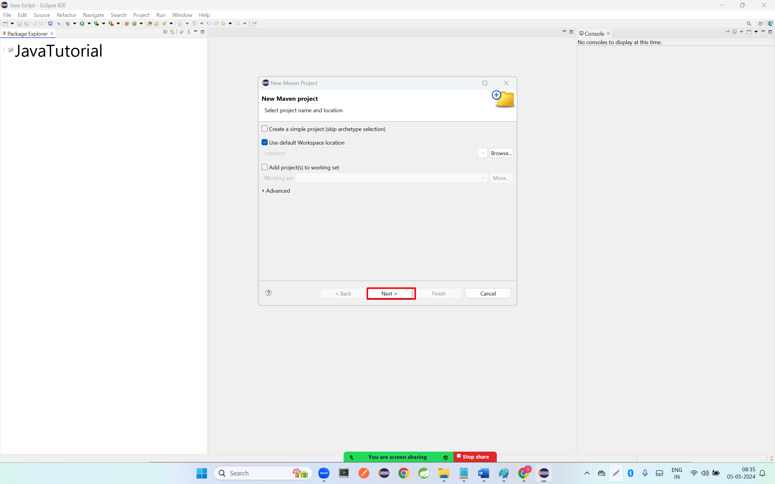

**Step 3: select internal option from catalog , select the maven-archtype-quickstart 1.1 version and click on next button**

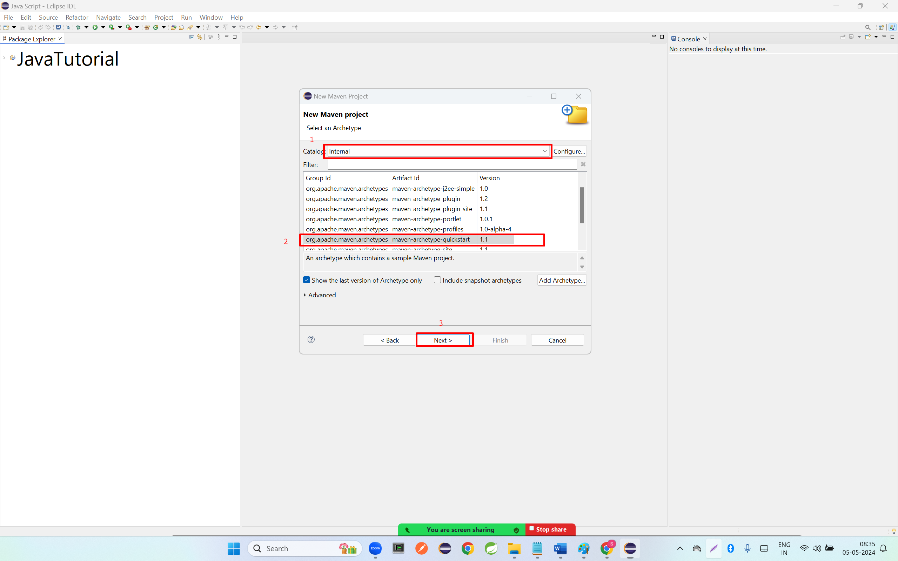

**Step 4: enter group id and artifact id and click on finish button**

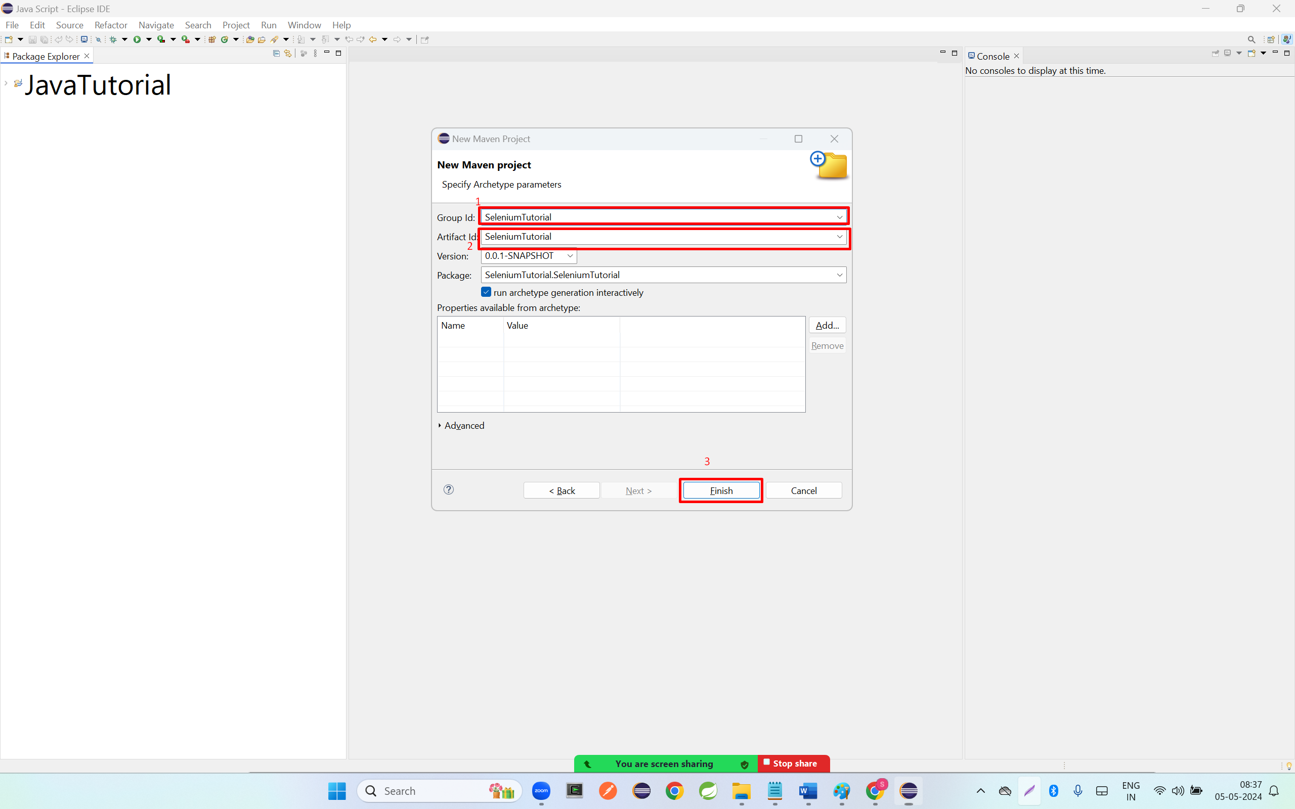

**Step 5: enter y keyword in console**

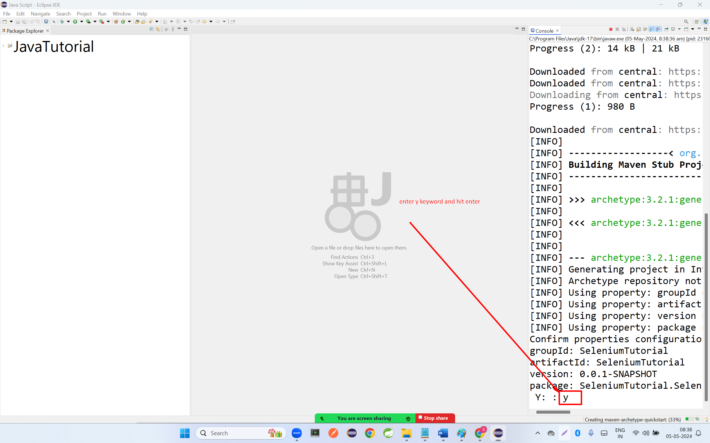

**Step 6: double click project name and click on pom.xml file**

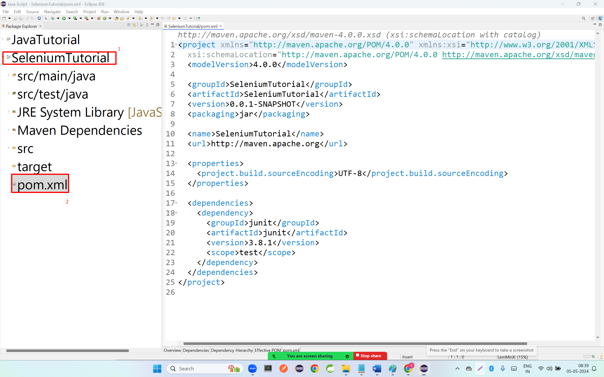

**Step 7: copy the dependency and paste in pom.xml file inside the dependencies tags.**

|  |
| --- |
| **<!-- https://mvnrepository.com/artifact/org.seleniumhq.selenium/selenium-java -->**  **<dependency>**  **<groupId>org.seleniumhq.selenium</groupId>**  **<artifactId>selenium-java</artifactId>**  **<version>3.141.59</version>**  **</dependency>** |

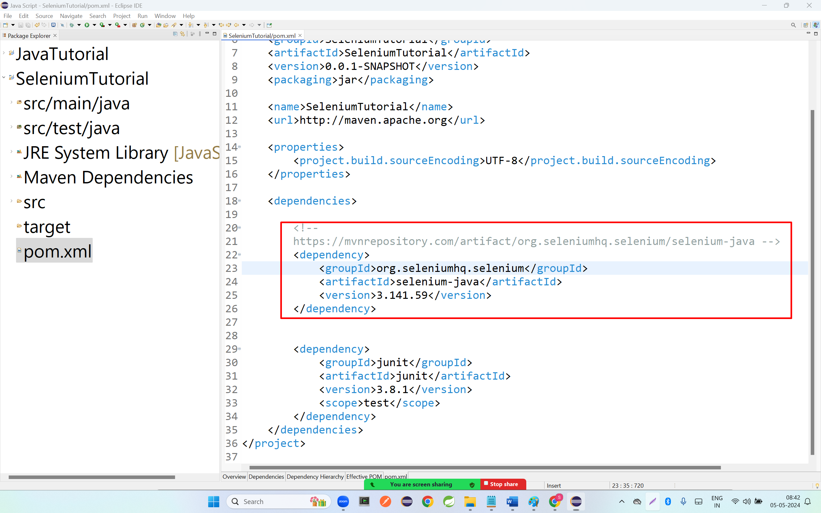

|  |
| --- |
| <project xmlns="http://maven.apache.org/POM/4.0.0"  xmlns:xsi="http://www.w3.org/2001/XMLSchema-instance"  xsi:schemaLocation="http://maven.apache.org/POM/4.0.0 http://maven.apache.org/xsd/maven-4.0.0.xsd">  <modelVersion>4.0.0</modelVersion>  <groupId>SeleniumTutorial</groupId>  <artifactId>SeleniumTutorial</artifactId>  <version>0.0.1-SNAPSHOT</version>  <packaging>jar</packaging>  <name>SeleniumTutorial</name>  <url>http://maven.apache.org</url>  <properties>  <project.build.sourceEncoding>UTF-8</project.build.sourceEncoding>  </properties>  <dependencies>  <!--  https://mvnrepository.com/artifact/org.seleniumhq.selenium/selenium-java -->  <dependency>  <groupId>org.seleniumhq.selenium</groupId>  <artifactId>selenium-java</artifactId>  <version>3.141.59</version>  </dependency>  <dependency>  <groupId>junit</groupId>  <artifactId>junit</artifactId>  <version>3.8.1</version>  <scope>test</scope>  </dependency>  </dependencies>  </project> |

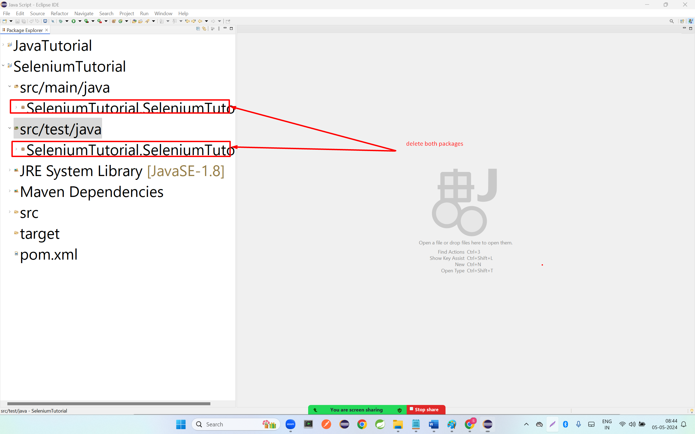

**Step 8; create new package and create new class**

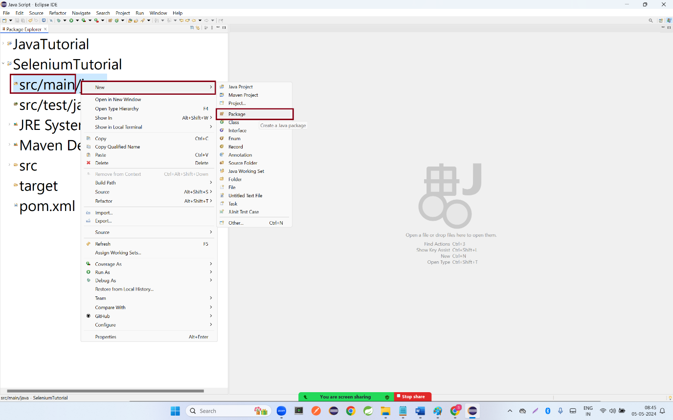

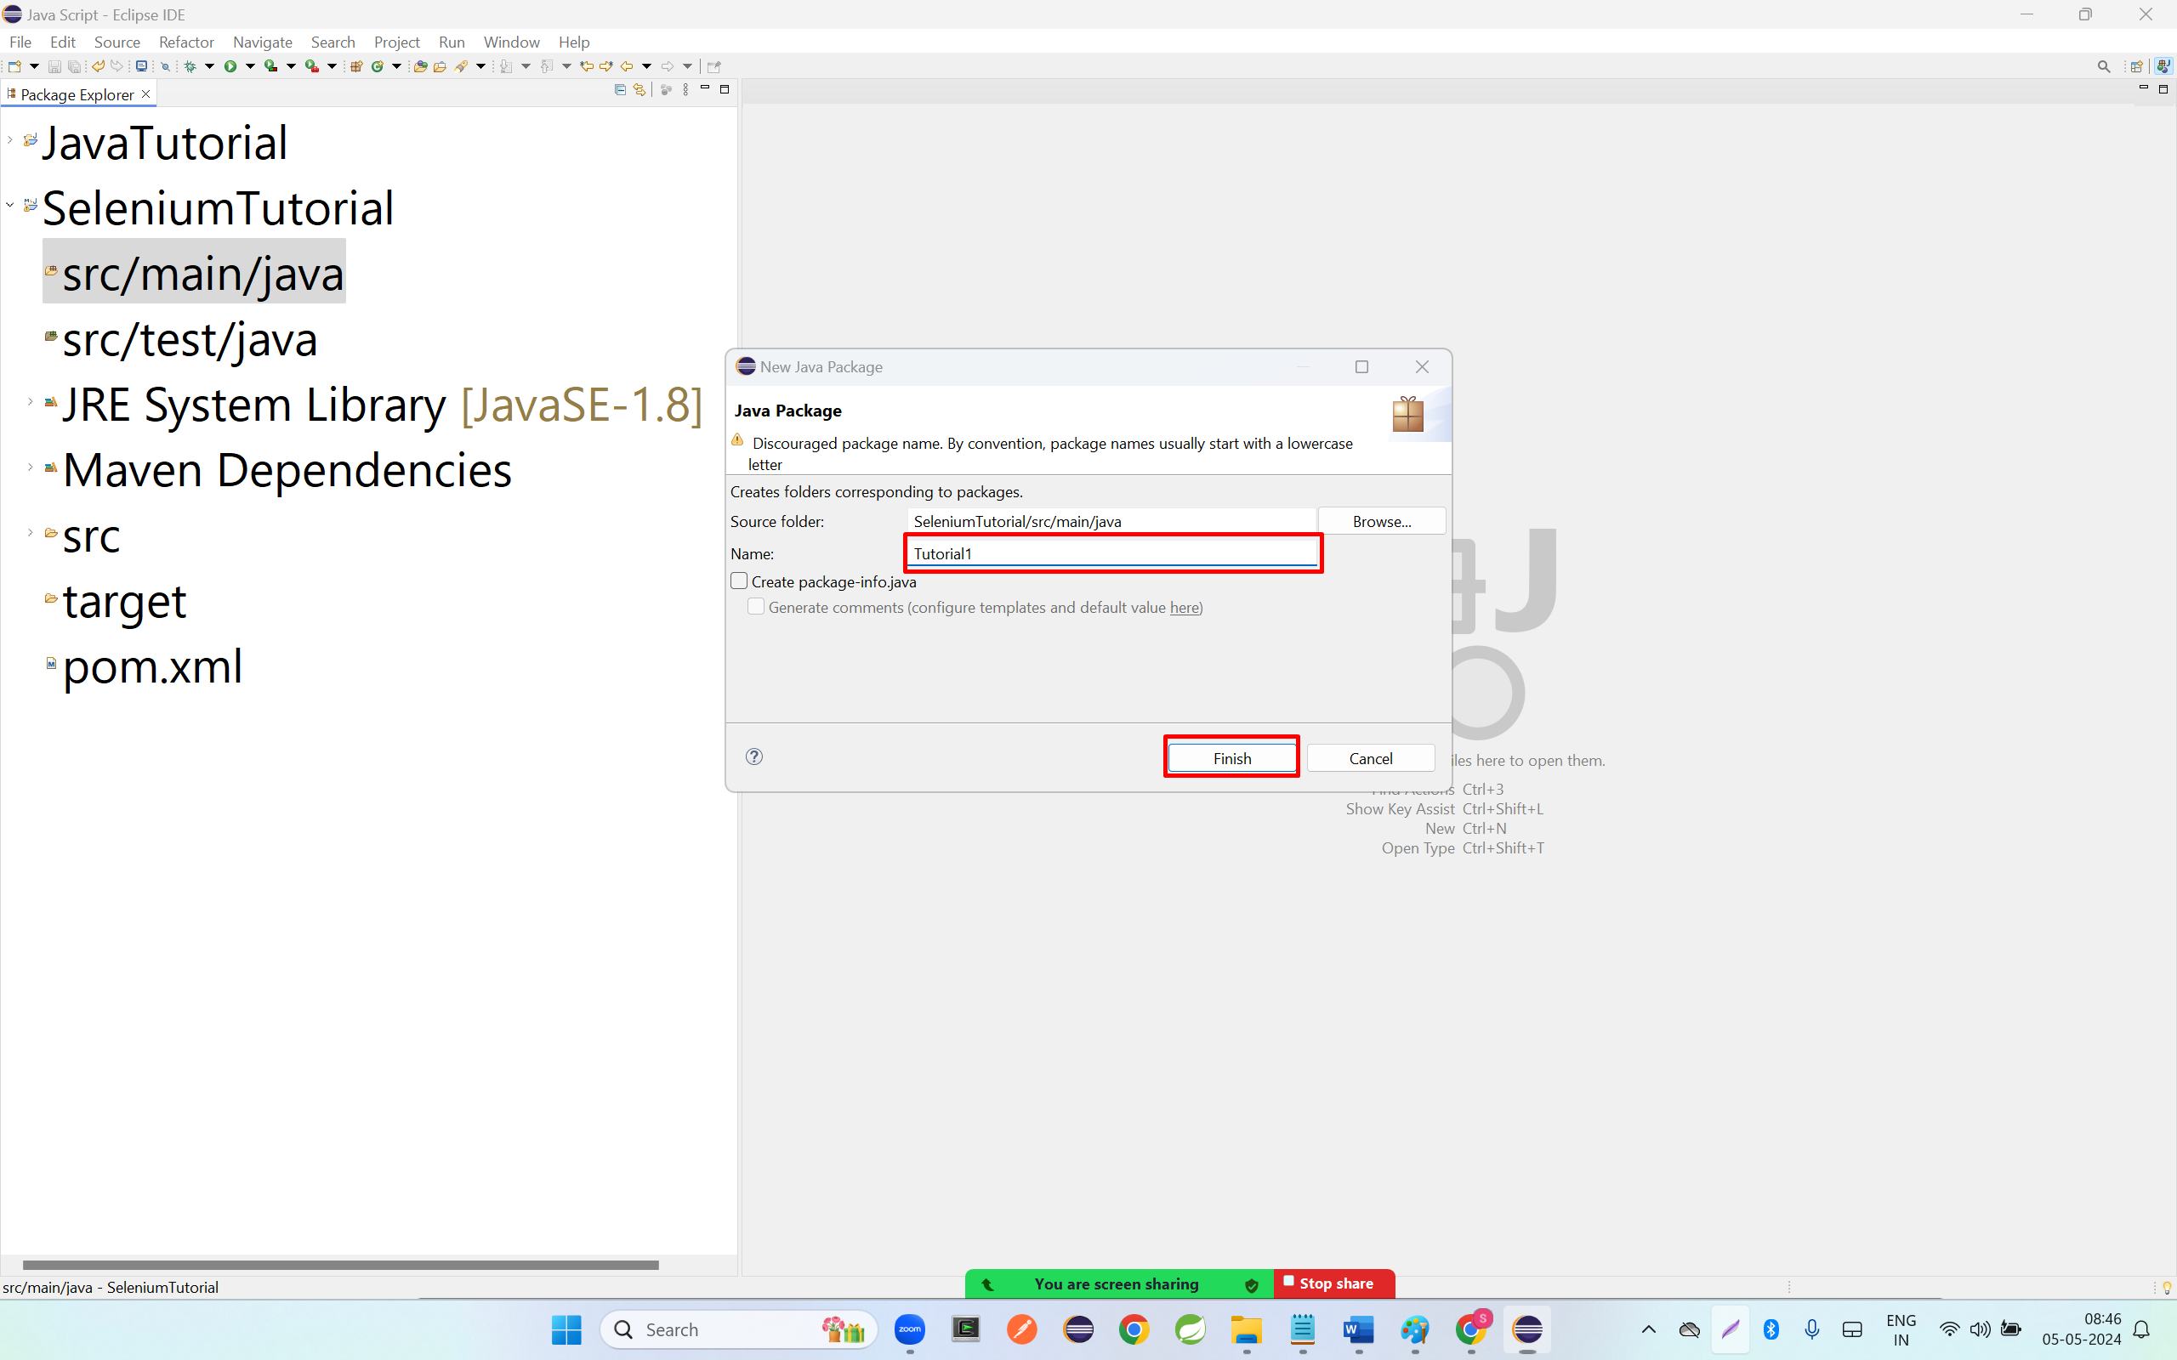

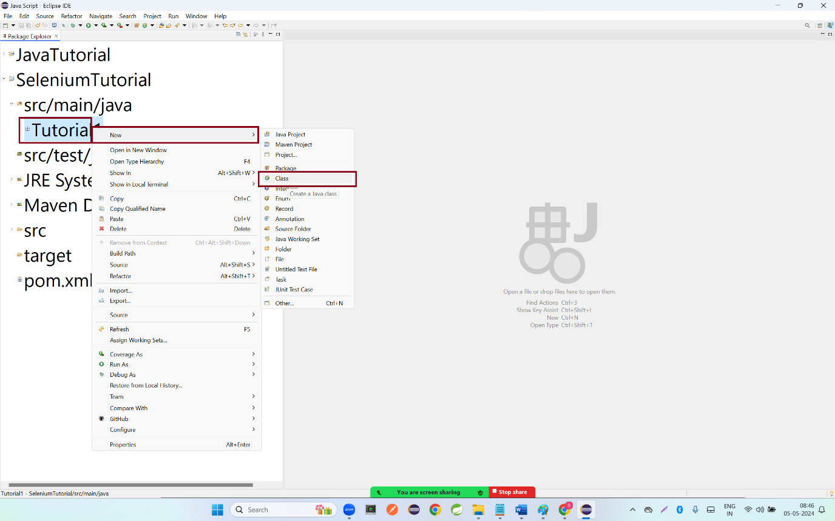

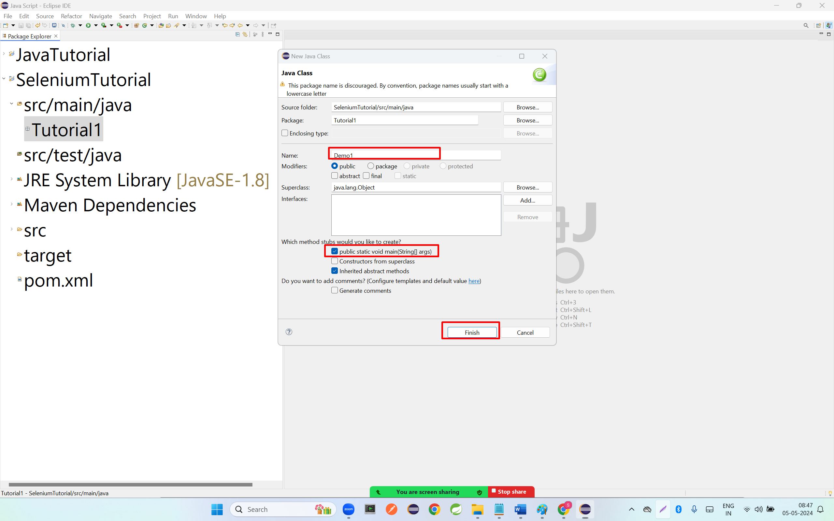

|  |
| --- |
| **package** Tutorial1;  **import** org.openqa.selenium.WebDriver;  **import** org.openqa.selenium.chrome.ChromeDriver;  **public** **class** Demo1 {  **public** **static** **void** main(String[] args) {  // Connect to the actual browser.  System.*setProperty*("webdriver.chrome.driver",  "C:\\Users\\praf0\\OneDrive\\Desktop\\Automation Testing 27th April 2024 Batch\\chromedriver-win64 (4)\\chromedriver-win64\\chromedriver.exe");  //Up casting-Reference of parent class and Object of child class.  //control+shift+o  WebDriver driver = **new** ChromeDriver();        }  } |